Outbound Voice & Appointment Automation System
GoHighLevel | Synthflow | Voice Agent | CRM | Outbound Calling | Appointment Booking

Project Overview
Built an outbound calling system for Jobilla using GoHighLevel and Synthflow.
The setup connects the voice agent with GoHighLevel workflows to manage outbound calls, appointment booking, and post call data inside the CRM.
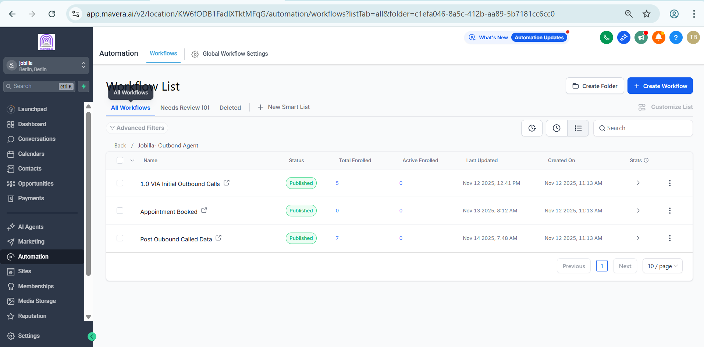
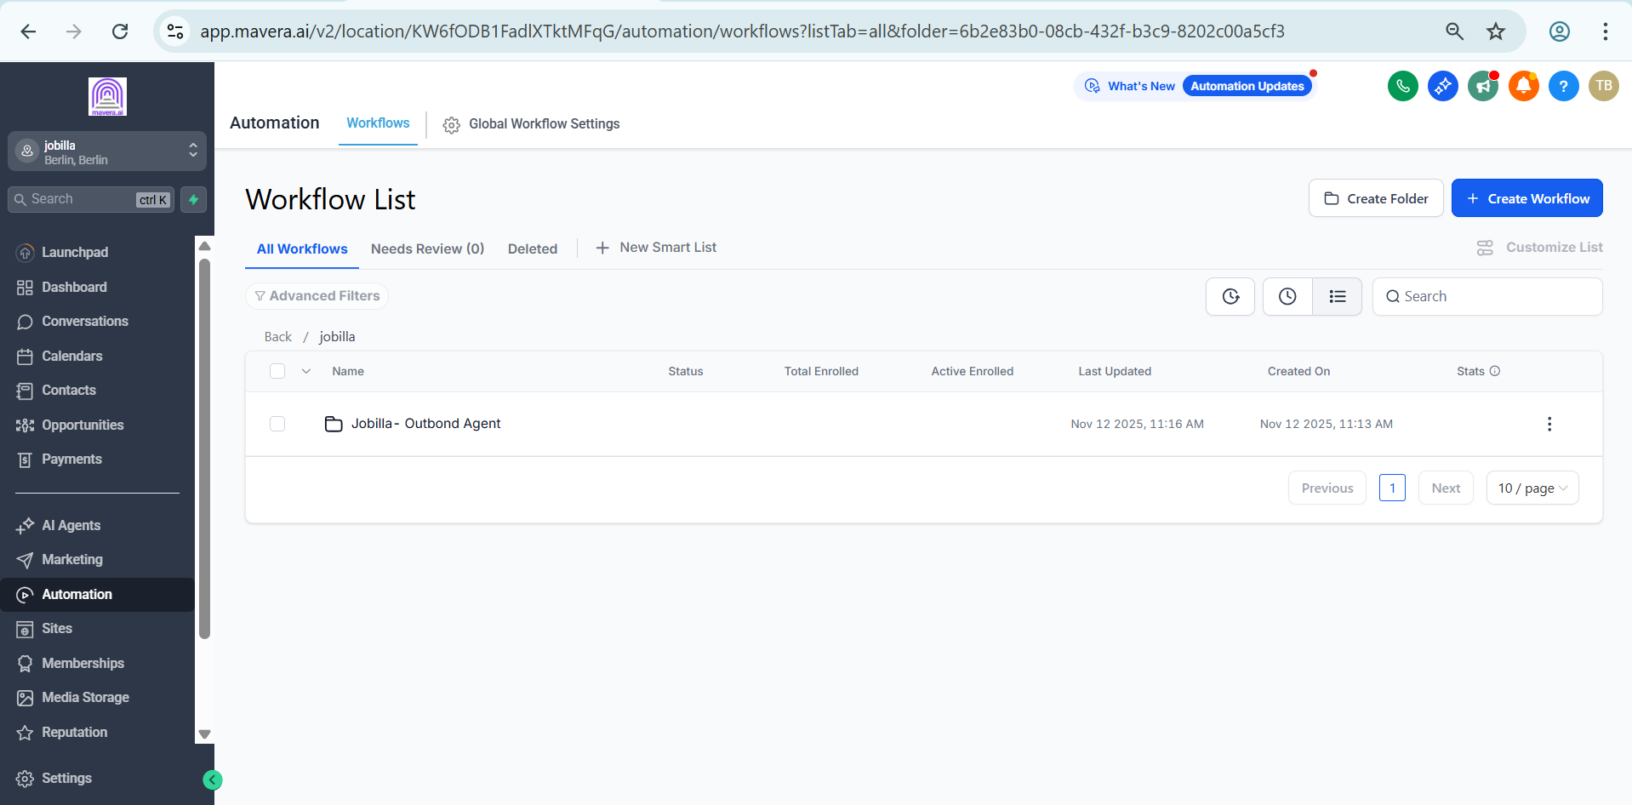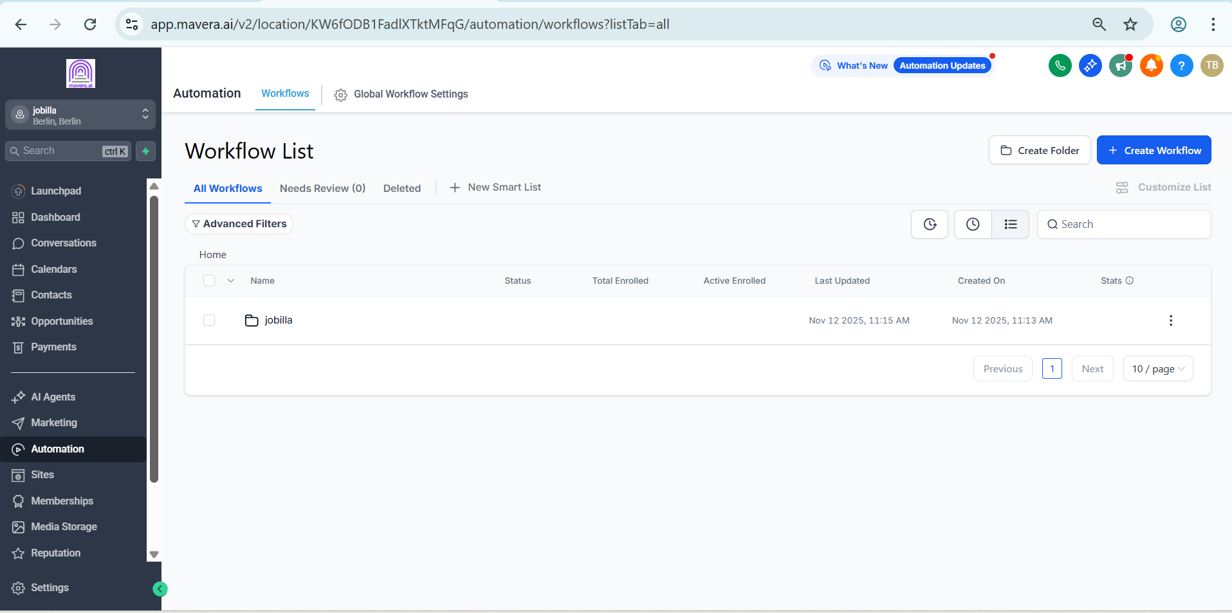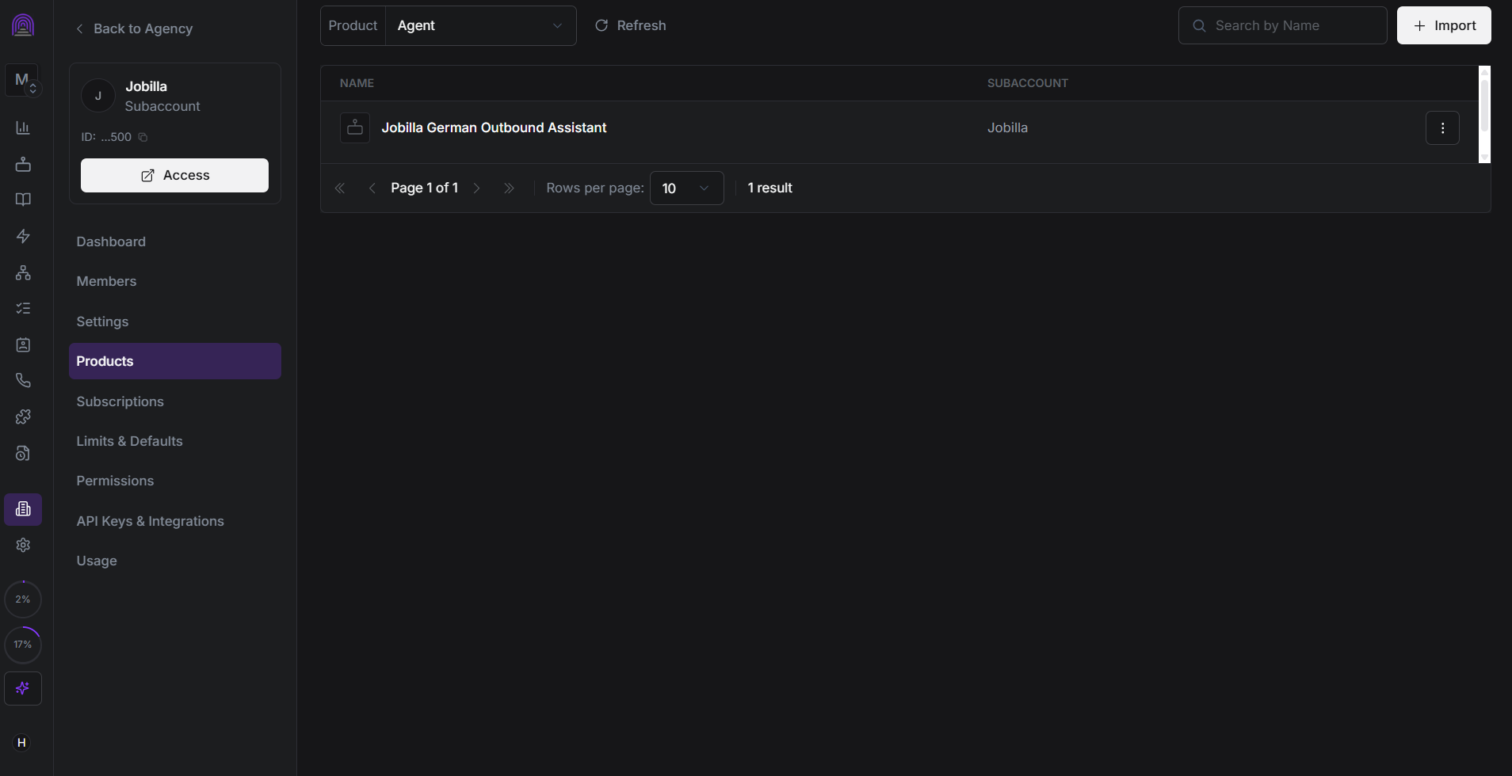

Voice Agent Setup
A dedicated Jobilla German Outbound Assistant was configured in Synthflow for outbound customer communication.
The agent is connected to the Jobilla GoHighLevel setup and handles the initial calling process.

GoHighLevel Workflows
The outbound system is organized into separate workflows:
• VA Initial Outbound Calls
• Appointment Booked
• Post Outbound Called Data
Each workflow handles a specific stage of the outbound process and keeps the lead information updated in the CRM.

Outbound Call Flow
The process works through:
Lead
↓
Initial Outbound Call
↓
Appointment Booking
↓
Post Call Data
↓
CRM Update
This keeps the calling and appointment process structured and ensures the result of each interaction is recorded.

Technology
• GoHighLevel
• Synthflow
• Voice Agent
• CRM Workflows
• Outbound Calling
• Appointment Automation

Result
A structured outbound calling system that connects voice calls, appointment booking, and CRM updates in one workflow.
The setup reduces manual calling and follow up work while keeping lead activity organized inside GoHighLevel.

